#! /bin/bash

**#Using loop display the number zero to nine?**

: 'for i in {0..9}

do

echo "Number $i"

done

'

**Output**

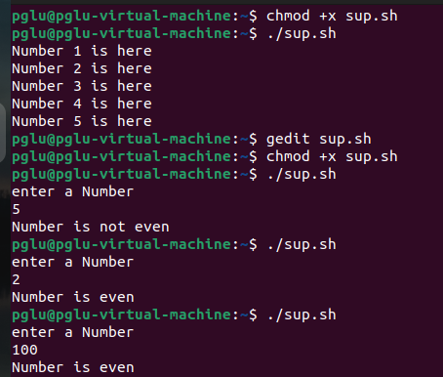

**#Write a Program so that loop terminates as soon as a becomes 5?**

i=0

while [ $i -le 5 ]

do

echo "Welcome $i"

((i++))

done

**Output**



**#Using if else statement check whether a number is even**

: '

echo "enter a Number"

read n

if [ $((n%2)) -eq 0 ]

then

echo "Number is even"

else

echo "Number is not even"

fi

'

**Output**

